Read, Cover, Remember, Retell, Bookmarks

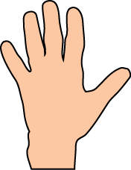
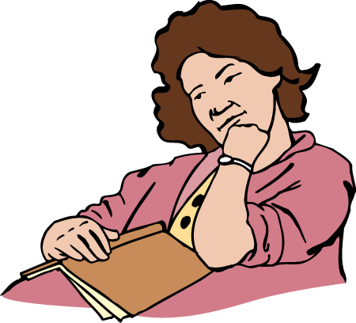
Cut these out and use with your books.
Read only as much
as your hand can cover.
Cover the words with your hand.
Remember what you have just read.
(It is OK to take another look.)
Retell what you
just read inside your head or to a partner.
Read
Cover
Remember
Retell
Read
Cover
Remember
REREAD!
(Think about why you are rereading.)

